Dp coin change
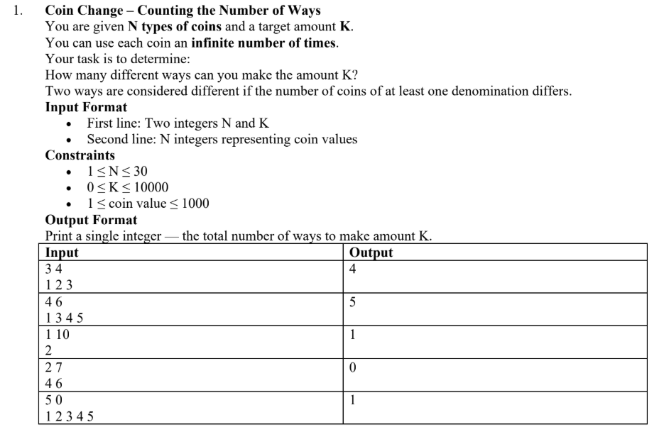
1.
#include<bits/stdc++.h>
using namespace std;
int COIN_CHANGE_WAYS(int coins[], int n, int target){
int dp [n+1][target+1];

for(int i=0;i<=n;i++){
dp[i][0]=1;
}
for(int j=1;j<=target;j++){
dp[0][j]=0;
}
for(int i=1;i<=n;i++){
for(int j=1;j<=target;j++){
if (coins[i-1] <= j){
dp[i][j] = dp[i-1][j] + dp[i][j - coins[i-1]];
}
else{
dp[i][j] = dp[i-1][j];
}
}
}
return dp[n][target];
}
int main(){
int n;
int target;
cout<< "enter num of coins:";
cin>> n;
cout<<"enter amount:";
cin>>target;
int coins[n];
for(int i=0;i<n;i++){
cin>>coins[i];
}

int total_ways = COIN_CHANGE_WAYS(coins, n, target);

cout<<"Number of ways:" <<total_ways <<endl;
}
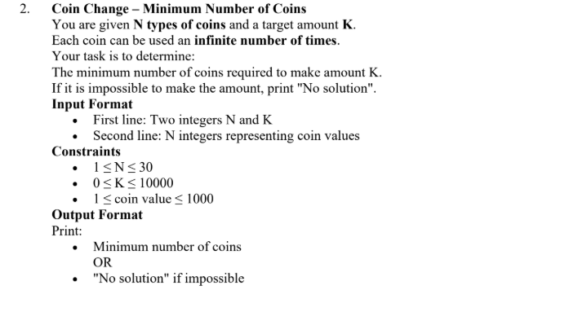
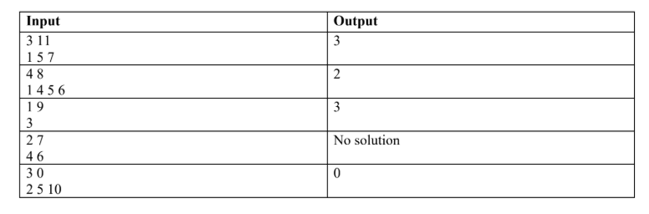
#include<bits/stdc++.h>
using namespace std;
int COIN_CHANGE(int coins[],int n,int target){
int dp[n+1][target+1];
for(int i=0;i<=n;i++){
dp[i][0]=0;
}
for(int j=1;j<=target;j++){
dp[0][j]=INT_MAX-1;
}
for(int i=1;i<=n;i++){
for(int j=1;j<=target;j++){
if (coins[i-1] <= j){
dp[i][j] = min (dp[i-1][j], 1 + dp[i][j - coins[i-1]]);
}
else{
dp[i][j] = dp[i-1][j];
}
}
}
if (dp[n][target] == INT_MAX-1){
return -1;
}
else{
return dp[n][target];
}
}
int main(){
int n;
int target;
cout<< "enter num of coins:";
cin>> n;
cout<<"enter amount:";
cin>>target;
int coins[n];
for(int i=0;i<n;i++){
cin>>coins[i];
}

int min_num = COIN_CHANGE(coins, n, target);
if(min_num == -1){
cout<< "No solution";
}
else{

cout<<"Minimum Number:" <<min_num <<endl;
}
}
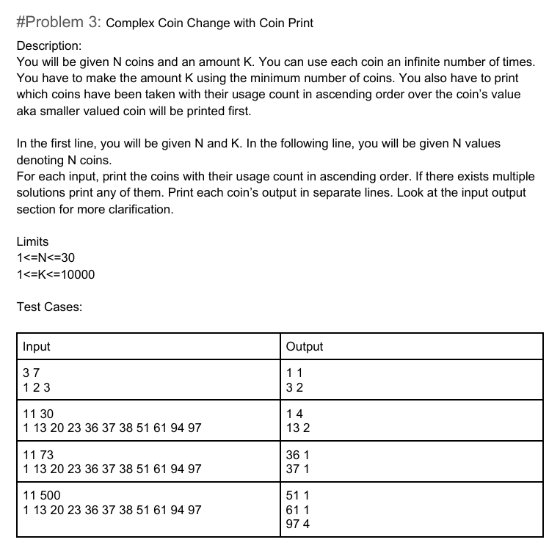
#include<bits/stdc++.h>
using namespace std;
const int INF = 1e9;
void bubbleSort(int coins[], int n){
for(int i = 0; i < n - 1; i++){
for(int j = 0; j < n - i - 1; j++){
if(coins[j] > coins[j + 1]){
swap(coins[j], coins[j + 1]);
}
}
}
}
void coinChange(int coins[], int n, int target){

int dp[n+1][target+1];
for(int i = 0; i <= n; i++){
dp[i][0] = 0;
}

for(int j = 1; j <= target; j++){
dp[0][j] = INF;
}
for(int i = 1; i <= n; i++){
for(int j = 1; j <= target; j++){

if(coins[i-1] <= j){

int take = 1 + dp[i][j - coins[i-1]];
int notTake = dp[i-1][j];

dp[i][j] = min(take, notTake);
}
else{
dp[i][j] = dp[i-1][j];
}
}
}
if(dp[n][target] >= INF){
cout << "No solution\n";
return;
}
cout << "Minimum coins: " << dp[n][target] << endl;
int count[n] = {0};
int i = n, j = target;
while(j > 0 && i > 0){
if(dp[i][j] == dp[i-1][j]){
i--; // skip coin
}
else{
count[i-1]++; // take coin
j = j - coins[i-1];
}
}
cout << "\nCoin usage:\n";
for(int k = 0; k < n; k++){
if(count[k] > 0){
cout << coins[k] << " " << count[k] << endl;
}
}
}
int main(){
int n, target;
cout << "Enter number of coins: ";
cin >> n;
cout << "Enter target amount: ";
cin >> target;
int coins[n];
cout << "Enter coin values: ";
for(int i = 0; i < n; i++){
cin >> coins[i];
}
bubbleSort(coins, n);
coinChange(coins, n, target);
return 0;
}
Dp 1.
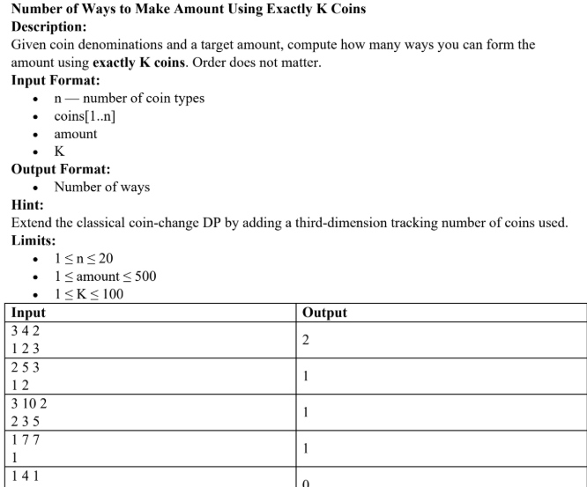
#include<bits/stdc++.h>
using namespace std;
long long Num_Ways(int coins[],int n, int amount ,int k){

long long dp[n+1][amount+1][k+1];
for(int i=0;i<=n;i++){
for(int j=0;j<=amount;j++){
for(int K=0;K<=k;K++){
dp[i][j][K]=0;
}
}
}
for (int i = 0; i <= n; i++){
dp[i][0][0] = 1;
}
for(int i=1;i<=n;i++){
for(int j=0;j<=amount;j++){
for(int K=0;K<=k;K++){
dp[i][j][K]=dp[i-1][j][K];
if(coins[i-1]<=j&&K>0){
dp[i][j][K]+=dp[i][j-coins[i-1]][K-1];
}
}
}
}
return dp[n][amount][k];
}
int main(){
int n,amount,k;
cout<<"Enter num of coins:";
cin>>n;
cout<<"Enter amount:";
cin>>amount;
cout<<"Enter exact num of coins (k) :";
cin>>k;
int coins[n];
cout<<"Enter coins :";
for (int i = 0; i < n; i++){
cin>>coins[i];
}
long long ways=Num_Ways(coins, n,amount,k);
cout<<"Num of ways: "<<ways<<endl;
return 0;
}
Dp 2.
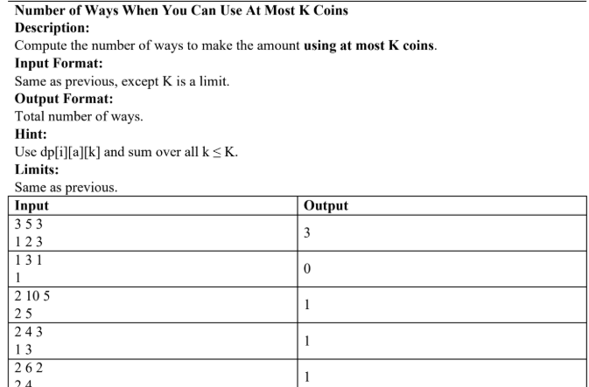

#include <bits/stdc++.h>
using namespace std;

long long Coin_Change_AtMostK(int coins[], int n, int amount, int K) {
long long dp[n+1][amount+1][K+1];
for(int i=0;i<=n;i++)
for(int j=0;j<=amount;j++)
for(int k=0;k<=K;k++)
dp[i][j][k] = 0;
for(int i=0;i<=n;i++)
dp[i][0][0] = 1;
for(int i=1;i<=n;i++){
for(int j=0;j<=amount;j++){
for(int k=0;k<=K;k++){
dp[i][j][k] = dp[i-1][j][k];
if(j >= coins[i-1] && k >= 1)
dp[i][j][k] += dp[i][j - coins[i-1]][k-1];
}
}
}
long long total = 0;
for(int k=0;k<=K;k++)
total += dp[n][amount][k];
return total;
}
int main() {
int n, amount, K;
cin >> n >> amount >> K;
int coins[n];
for(int i=0;i<n;i++) cin >> coins[i];
cout << Coin_Change_AtMostK(coins, n, amount, K) << endl;
return 0;
}
3.
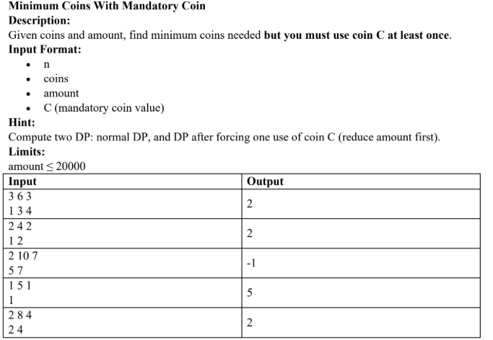

#include <bits/stdc++.h>
using namespace std;

int MinCoinsMandatory(int coins[], int n, int amount, int C) {
int INF = 1e9;
if(C > amount) return -1;
int remaining = amount - C;

int dp[n+1][remaining+1];
for(int i=0;i<=n;i++)
for(int j=0;j<=remaining;j++)
dp[i][j] = INF;
for(int i=0;i<=n;i++)
dp[i][0] = 0;
for(int i=1;i<=n;i++){
for(int j=0;j<=remaining;j++){
dp[i][j] = dp[i-1][j];
if(j >= coins[i-1] && dp[i][j - coins[i-1]] != INF)
dp[i][j] = min(dp[i][j], dp[i][j - coins[i-1]] + 1);
}
}
if(dp[n][remaining] == INF) return -1;
return dp[n][remaining] + 1;
}
int main() {
int n, amount, C;
cout << "Enter number of coins and target amount: ";
cin >> n >> amount;
cout << "Enter mandatory coin value: ";
cin >> C;
int coins[n];
cout << "Enter the coin values: ";
for(int i=0;i<n;i++)
cin >> coins[i];
int ans = MinCoinsMandatory(coins, n, amount, C);
cout << "Minimum coins needed (or -1 if impossible): " << ans << endl;

return 0;
}
4.
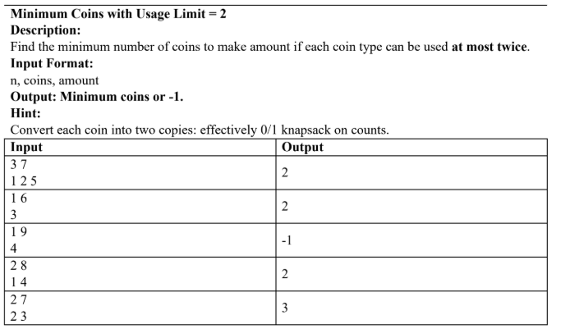
#include <bits/stdc++.h>
using namespace std;

int MinCoinsUsageLimit(int coins[], int n, int amount){
int INF = 1e9;
int expanded[2*n];
int m = 0;
for(int i=0;i<n;i++){
expanded[m++] = coins[i];
expanded[m++] = coins[i];
}

int dp[m+1][amount+1];
for(int i=0;i<=m;i++)/
for(int j=0;j<=amount;j++)
dp[i][j] = INF;

for(int i=0;i<=m;i++) dp[i][0] = 0;

for(int i=1;i<=m;i++){
for(int j=0;j<=amount;j++){
dp[i][j] = dp[i-1][j];
if(j >= expanded[i-1] && dp[i-1][j - expanded[i-1]] != INF)
dp[i][j] = min(dp[i][j], dp[i-1][j - expanded[i-1]] + 1);
}
}
if(dp[m][amount] == INF) return -1;
return dp[m][amount];
}

int main(){
int n, amount;
cout << "Enter number of coins and target amount: ";
cin >> n >> amount;

int coins[n];
cout << "Enter coin values: ";
for(int i=0;i<n;i++) cin >> coins[i];

int ans = MinCoinsUsageLimit(coins, n, amount);
cout << "Minimum coins needed (or -1 if impossible): " << ans << endl;

return 0;
}

LCS
1.
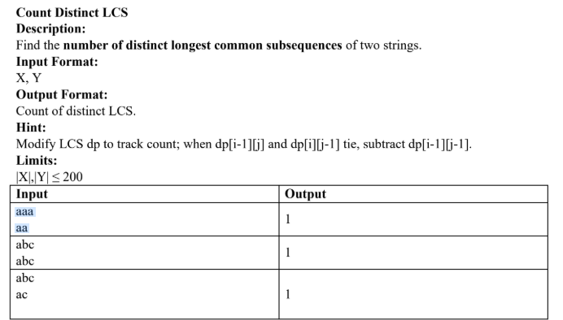
#include<bits/stdc++.h>
using namespace std;
int count_Distinct_LCS(string X,string Y)
{
int n=X.size();
int m=Y.size();
int dp[n+1][m+1];
int c[n+1][m+1];
for(int i=0; i<=n; i++)
{
dp[i][0]=0;
c[i][0]=1;
}
for(int j=0; j<=m; j++)
{
dp[0][j]=0;
c[0][j]=1;
}
for(int i=1; i<=n; i++)
{
for(int j=1; j<=m; j++)
{
if(X[i-1]==Y[j-1])
{
dp[i][j] = dp[i-1][j-1]+1;
c[i][j]=c[i-1][j-1];
}
else
{

if(dp[i-1][j] > dp[i][j-1])
{
dp[i][j] = dp[i-1][j];
c[i][j] = c[i-1][j];
}
else if(dp[i-1][j] < dp[i][j-1])
{
dp[i][j] = dp[i][j-1];
c[i][j] = c[i][j-1];
}
else
{
dp[i][j] = dp[i-1][j];
c[i][j] = c[i-1][j] + c[i][j-1];
if(dp[i-1][j-1] == dp[i][j])
c[i][j] -= c[i-1][j-1];
}
}
}

}return c[n][m];
}
int main(){
string X,Y;
cin>>X>>Y;
int Count=count_Distinct_LCS( X, Y);
cout<<"Ans :"<<Count<<endl;
return 0;
}

2.
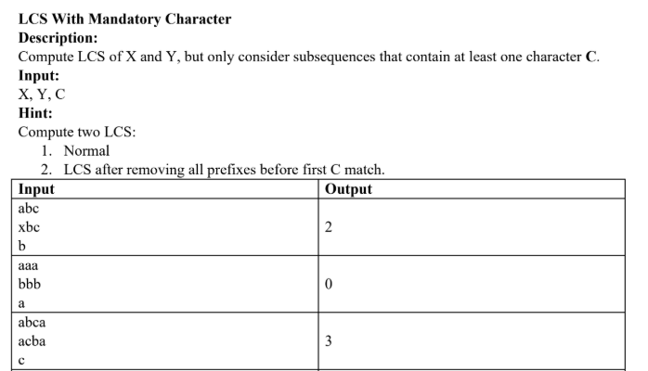
#include<bits/stdc++.h>
using namespace std;

// 🔷 Normal LCS function
int LCS(string X, string Y){
int n = X.size();
int m = Y.size();

int dp[n+1][m+1];

for(int i=0;i<=n;i++){
for(int j=0;j<=m;j++){
dp[i][j] = 0;
}
}

for(int i=1;i<=n;i++){
for(int j=1;j<=m;j++){
if(X[i-1] == Y[j-1]){
dp[i][j] = 1 + dp[i-1][j-1];
}
else{
dp[i][j] = max(dp[i-1][j], dp[i][j-1]);
}
}
}

return dp[n][m];
}

// 🔷 Main function
int main(){

string X, Y;
char C;

cin >> X >> Y >> C;

int n = X.size();
int m = Y.size();

int ans = 0;

// 🔥 try all positions where C matches in both strings
for(int i=0;i<n;i++){
if(X[i] != C) continue;

for(int j=0;j<m;j++){
if(Y[j] != C) continue;

// left part LCS
int left = LCS(X.substr(0,i), Y.substr(0,j));

// right part LCS
int right = LCS(X.substr(i+1), Y.substr(j+1));

// total = left + 1(C) + right
ans = max(ans, left + 1 + right);
}
}

cout << ans << endl;

return 0;
}

#include <bits/stdc++.h>
using namespace std;

int main() {
string X, Y;
cin >> X >> Y;

int n = X.size();
int m = Y.size();

int dp[n+1][m+1];
char b[n+1][m+1];

for(int i = 0; i <= n; i++) {
for(int j = 0; j <= m; j++) {

if(i == 0 || j == 0) {
dp[i][j] = 0;
b[i][j] = '0';
}

else if(X[i-1] == Y[j-1]) {
dp[i][j] = 1 + dp[i-1][j-1];
b[i][j] = 'D';
}

else if(dp[i-1][j] >= dp[i][j-1]) {
dp[i][j] = dp[i-1][j];
b[i][j] = 'U';
}

else {
dp[i][j] = dp[i][j-1];
b[i][j] = 'L';
}
}
}

// Backtracking to get LCS string
string lcs = "";
int i = n, j = m;

while(i > 0 && j > 0) {
if(b[i][j] == 'D') {
lcs += X[i-1];
i--;
j--;
}
else if(b[i][j] == 'U') {
i--;
}
else {
j--;
}
}

reverse(lcs.begin(), lcs.end());

cout << "LCS length: " << dp[n][m] << endl;
cout << "LCS: " << lcs << endl;

return 0;
}

